Ai-Healthcare Chatbot System

A Dissertation submitted
for the partial fulfillment of the degree of
Bachelor of Engineering in
Computer engineering
(Session 2016 -2020 )

Guided By: Submitted By:
Dr. Hemant Makwana Arvind sisodiya(16C8108)
Amit porwal (16C8104)
Durgesh barde(16C8114)

Department of Computer Engineering
Institute of Engineering & Technology
Devi Ahilya Vishwavidyalaya, Indore (M.P.)
(www.iet.dauniv.ac.in)
July 2020

Dissertation Approval Sheet

The dissertation entitled “Ai-Healthcare Chatbot System” submitted by arvind sisodiya , durgesh barde , Amit porwal is approved as partial fulfillment for the award of Bachelor of Engineering in Computer Engineering degree by Devi Ahilya Vishwavidyalaya, Indore.

Internal Examiner External Examiner

Director
Institute of Engineering & Technology
Devi Ahilya Vishwavidyalaya,
Indore (M.P.)

Recommendation

The dissertation entitled “Ai-Healthcare Chatbot System” submitted by ( arvind sisodiya , durgesh barde , amit porwal ) is a satisfactory account of the bonafide work done under my supervision is recommended towards the partial fulfillment for the award of Bachelor of Engineering in Computer Engineering degree by Devi Ahilya Vishwavidyalaya, Indore.

Date: Name of Project Guide
Dr. Hemant makwana

Endorsed By :
Head, Department of Computer Engineering

Candidate Declaration

We hereby declare that the work which is being presented in this project entitled Ai-Healthcare Chatbot System in partial fulfillment of degree of Bachelor of Engineering in Name of the Branch is an authentic record of our own work carried out under the supervision and guidance of Dr. Hemant makwana , in Department of Information Technology, Institute of Engineering and Technology, Devi Ahilya Vishwavidyalaya, Indore
We are fully responsible for the matter embodied in this project in case of any discrepancy found in the project and the project has not been submitted for the award of any other degree.
Date:
Place:

ACKNOWLEDGEMENTS

I would like to take this opportunity to thank my project supervisor Dr. Hemant makwana for his continuous guidance and encouragement throughout the entirety of the project. I would also like to thank our HOD Dr G.L. Prajapati for his feedback and guidance during the development stage. Finally I would to thanks our director Dr. Sanjeev tokekar his guidance and valuable and critical input on the Testing and Evaluation Chapters.

ABSTRACT

To live a good life health care is vital factor for individuals. But it is not so easy to consult the doctor in case of any health related issues. The proposed idea is to create chatbot for healthcare as virtual assistant using Artificial Intelligence. Artificial intelligence integrated healthcare chatbot which will diagnose and provides the common health issues details before consulting a doctor. Healthcare chatbot system will use natural language processing and neural networks to train the medical database. To reduce the healthcare overall costs and improve accessibility to medical knowledge the healthcare chatbot is built. There are certain chatbots are existing that acts as medical reference books that helps the patients to know additional information about their disease and helps to improve their health. This chatbot system engages with patients using text-to-text conversation about their health issues and provides the personalized diagnosis based on their symptoms. Hence, individuals will have the knowledge about their health status and will get to know about right treatments.

TABLE OF CONTENTS Page No
Dissertation Approval Sheet i
Recommendation ii
Candidate Declaration iii
Acknowledgements iv
Abstract v
List of figures vi
List of Tables vii
Chapter 1 Introduction
  - Overview and issues involved 1
  - Problem Definition 2
  - Proposed Solution 3
  - Technologies Used 4
Chapter 2 Literature Survey
2.1 Methodology 5
2.2 Technologies and Tools 5
2.3 Existing Solutions 6
Chapter 3 Analysis
3.1 Software Requirements 7
3.2 Hardware Requirements 7
3.3 Use Case Model 7
3.4 Use Case Description 8
Chapter 4 Design
4.1 Technology Selection 9
4.2 Sequence diagrams and Activity diagrams. 10
4.3 Class Diagram 11 Chapter 5 Implementation and Testing
5.1 Subsystem and Their Dependencies 12
5.2 Class diagram explanation in detail. 13
5.3 Test Cases 14
Chapter 6 Conclusion 15
References 16
Appendix

List of Figures

Fig no Title

1.1 Flowchart

1.2 functional architecture

3.1 Use Case diagram

4.1 Sequence diagram

4.2 Activity diagram

5.1 Turing test

5.2 Project demo

Chapter-1

Introduction

  - Overview and issues involved

Artificial Intelligence is based on how any device perceives its Environment and takes actions based on the perceived data to achieve the result successfully. It is the study of intelligent agents. Artificial Intelligence gives the ability of thinking and behaving like humans to a computer.A chatbot is also known as a talkbot, chatterbot , Bot,interactive agent etc.is a computer program which conducts a conversation via voice or text methods and thereby it acts as a conversational partner rather than humans. For various practical purposes like customer service or information acquisition, healthcare chatbot is being used now a days. Mostly chatbots uses natural language processing for interpreting the user input and generates the corresponding response but certain simpler systems searches for the keyword within the text and then provides a reply based on the matching keywords or certain pattern. Trending, chatbots are part of virtual assistants such as Google Assistant, Siri, and Alexa are being used by many organizations' apps, websites, and on instant messaging platforms. Non-assistant applications include chatbots used for entertainment purposes, for research, and social bots which promote a particular product, candidate, or issue. Chatbot’s are such kind of computer programs that interact with users using natural languages. For all kind of chatbots the flow is same, though each chatbot is specific in its own area knowledge that is one input from human is matched against the knowledge base of chatbot.

  - Problem definition

1.2.1 Imbalance between health workforce and patients: It is a major challenge in healthcare sector, as imbalances between health workforce or lower health professionals leads to lower quality and productivity of medical services, increasing wait time, diversion of emergency department of patients.
1.2.2 Human errors in medical diagnosis: Diagnostic Error is concern with the failure of establish an accurate and timely explanation of the patient's health problem or that explanation to the patient. This can cause serious health risk.
1.2.3 Increasing individual healthcare expenses: This is the most common issue in healthcare sector for consulting a healthcare professional diagnosis and medication cost are too high.
1.2.4 Real time health monitoring: There is not any system available that will monitor our health in real time because less number of healthcare workforce that leads to lack of personal assistance of the patient health.
1.2.5 unnecessary diagnostic tests: unnecessary diagnostic tests lead to expensive medical services. Not all people can afford that much high cost of health consultation.
1.2.6 continuous shortage of nursing and technician staff: lack of access to healthcare, especially in rural areas. Currently available physicians for the general population has not been able to keep up with the current healthcare demand. Healthcare service providers have been pressured to take care of more patients than they can handle, leading to lower quality of care.

  - Proposed solution

Chabot works basically on Artificial intelligence, so using this capability we have decided to add some contribution to the Healthcare sector. In the proposed system the user interaction is a linear design that process from symptom extraction, to symptom mapping, where it identifies the corresponding symptom, then diagnosis the patient whether it’s a major or minor disease and suggests the disease type and treatement. details will be extracted from the database that already trained. our healthcare chatbot system can often be benificial to the lack of patient engagement after they leave clinics or hospitals. Various surveys in this area have proved that that chatbot can provide healthcare in low costs . We have used chatterbot python library module for creating the ai-healthcare chatbot system . We have developed artificial intelligence healthcare chatbot system that can be used to eliminate the above problems regarding common health issues. This healthcare chatbot will not save personal information of any user. Chatbots don’t have that much level of cognitive intelligence that will take accurate decisions. We will add custom google search to eliminate the decision making of chatbot so that the people can find out detailed information about their health issues. By adding custom google search from some trusted sites will provide in depth knowledge from multiple sources. This software is built using natural language processing and chatterbot (a python library module).
We have trained a chatbot using Chatterbot . We have trained the bot to identify certain types of keywords in order to recognize the user's input. This information is then forwarded to the backend.

1.3.1 Technologies used:

1.3.2 Natural Language Processing:

Natural Language Processing (NLP) is the study of computer programs to understand human Language. The ultimate goal of NLP is to read, translate, understand and make sense of the human languages.NLP will be used to understand the input(syntax) given by the user for automatic analysis and representation of human language that machine can understand.We will use datasets to train the model.It will perform the sentimental analysis of trained datasets and will diagnose the diseases based on input symptoms.

1.3.3 Chatterbot:

ChatterBot is a conversational dialog engine based on machine-learning algorithms. chatterbot is build in Python which generates responses based on collections of already known conversations. The language independent design of ChatterBot be trained to speak any language. It is simple and easy to use for building a chatbot.

1.3.4 Flask(web framework):

We have used flask web framework for creating the web based user interface of ai healthcare chatbot system.Flask is also known as microweb framework and It is easy to use , quick to learn , and also easy for creating web applications.

1.3.5 Flow diagram:
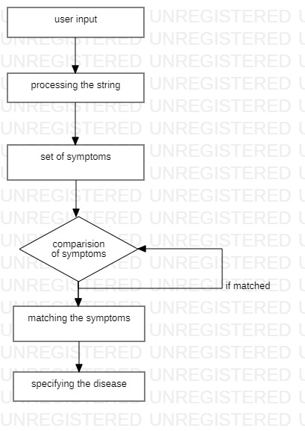

Fig 1.1 flow diagram

1.3.6 functional architecture:

The Figure proceeds with the users interaction where the users’ details will be stored in the database. Then the user can start their conversation with the chatbot and it will be stored in the database for future reference. The chatbot will clarify the users symptoms with serious of questions and the symptom conformation will be done. The disease will be categorized as minor and major disease. Chatbot will reply whether it’s a major or minor disease. If it’s a major one user will be suggested with the doctor details for further treatment.

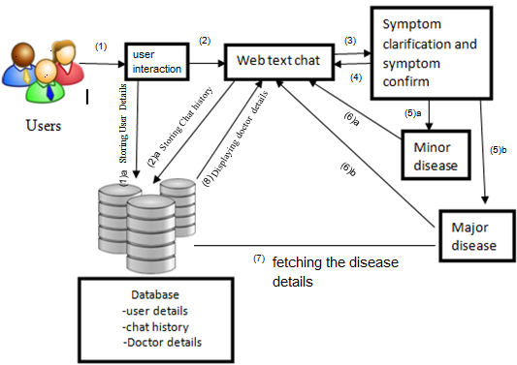

Fig 1.2 functional architecture

Chapter-2

Literature Survey

2.1 Methodology

2.1.1 We have trained a chatbot using Chatterbot. We have trained the bot to identify certain types of keywords in order to recognize the user's input. This information is then forwarded to the backend.
2.2.2 The chatbot is connected to the backend using a flask. Flask is a web framework. This means flask provides you with tools, libraries and technologies that allow you to build a web application. This web application can be some web pages, a blog, a wiki or go as big as a web-based calendar application or a commercial website. Every time the chatbot performs an action, it is done in the form of a request. All the requests managed by Flask application, which also handles the frontend.
2.2.3 As the flask web framework is the interface between the chatbot and the backend, the backbend’s task is to translate it to an action in the database. Again, this part is performed under Flask using Python code.

2.2 Existing solutions:

There are lots of artificial intelligence chatbots are available that provides personalized health diagnosis. Using Machine learning complex algorithms to analyze and take accurate decisions to provide relevant treatments and products and services.
One of the trending application of artificial intelligence healthcare bot is Your.MD founded on 2012.This web application can be used by patients as well as clinicians.Your.MD application can provide self-diagnosis based on trained models. Algorithms trained on validated medical reports over 1000 medical conditions on different types of diseases. Another one trending mobile application is Sensely founded on 2013.This is a mobile application that can take user input in multiple formats like chat images and in video format. Virtual medical assistant of sensely integrates artificial intelligence to recommend diagnosis on the basis of patient symptoms using smartphone. Sensely platform algorithms trained on large volume of medical data such as medical chronic disease information and medical protocols to analyze the patient symptoms and recommends appropriate diagnosis. For example patients can describe their symptoms to the virtual medical chatbot using speech or text and it will provide the proper treatment. Buoy Health chatbot algorithm was trained on huge volume of clinical data from different medical conditions. This all healthcare chatbots are equipped with artificial intelligence but some weaknesses are also existing there. Some of cons of this applications like they needs active internet connection, data privacy, complex user interface requires lot of time to understand, decision making is very poor that leads to people don’t trust on such digital healthcare chatbots.

2.3 Artificial intelligence in healthcare:

Artificial intelligence in healthcare uses the deep learning neural networks and uses the human cognitive analysis for diagnosis of different types of diseases from the huge volume of complicated medical data. There is huge different from AI technologies from traditional technologies in healthcare is the ability to process data and give well defined outputs based on machine learning algorithms. This algorithms can recognize the patterns using classification and create its own logic. The main goal of artificial intelligence in healthcare systems is the analysis of relationship between treatment and prevention techniques and patient health diagnosis. AI healthcare programs have been developed and implemented to treatment protocol development, diagnosis processes, personalized health assistant and patient monitoring etc. Companies such as IBM and google also working on development of healthcare algorithms. Artificial intelligence in healthcare is cutting edge technology that can detect the cancer cells through radiology.

2.4 Technologies and Tools used:

We used the following tools to implement the project -
- HTML + CSS (for frontend)
- Python + libraries such as Flask (for backend)
- SQLite (for database)
- Chatterbot, a conversational dialogue engine (for chatbot processing)
- Natural language processing
2.4.1 Natural Language Processing:

Natural Language Processing (NLP) is the study of computer programs to understand human Language. The ultimate goal of NLP is to read, translate, understand and make sense of the human languages. Natural language processing will be used to understand the input (syntax) given by the user for automatic analysis and representation of human language that machine can understand. We will use datasets to train the model. It will perform the sentimental analysis of trained datasets and will diagnose the diseases based on input symptoms.

2.4.2 Chatterbot:

Chatterbot is a conversational dialog engine based on machine-learning algorithms. Chatterbot is build in Python which generates responses based on collections of already known conversations. The language independent design of Chatterbot be trained to speak any language. It is simple and easy to use for building a chatbot.

2.4.5 Flask(web framework):

We have used flask web framework for creating the web based user interface of ai healthcare chatbot system.Flask is also known as microweb framework and It is easy to use , quick to learn , and also easy for creating web applications.

Chapter-3

Analysis

  - Software Requirements:

Operating System : Windows or Linux
Programming language: Python,
Python modules: NLP(natural language processing), chatterbot
Web Technology: flask a python web framework

  - Hardware Requirements:

Processor : Pentium IV(minimum)
Hard Disk : 40GB
RAM : 256MB (minimum)
3.3 Use Case Model
A use case diagram shows a set of use cases and actors and their relationships. Use case diagrams address the static use case view of system. These diagrams are especially important in organizing and modelling the behaviors of a system. Use case diagrams commonly contains Use cases,Actors, Dependency, generalization and association relationships. 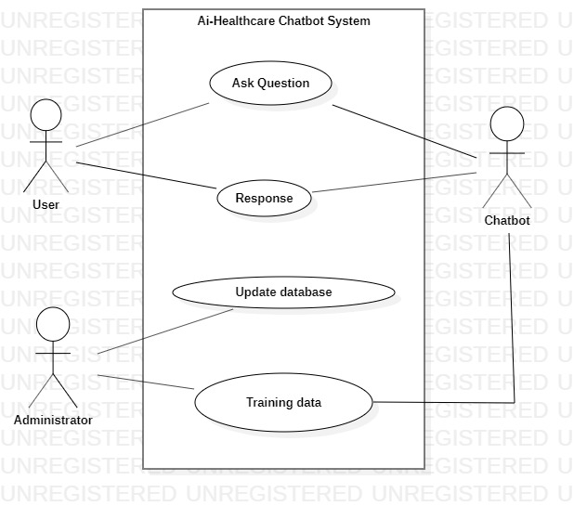
Fig 3.1 Use case diagram
3.4 Use Case Description
3.4.1 Ask Question
- Brief Description: User or chatbot can ask any kind ofquestions.
- User: Any active user,chatbot.
- Input Data: question asked by theuser.
- Output Data: reply by thechatbot
- Pre-conditions: chatbot should be active and connected to datafile
3.4.2 Reply
- Brief Description: the reply chatbot or user is framed upon the question asked by the user or chatbot.
- User: Chatbot any active user.
- Input Data: question asked by the user or chatbot.
- Output Data: reply by the chatbot or user.
- Pre-conditions: chatbot should be active and connected to datafiles.
3.4.3 Update data in sqlite3 db
- Brief Description: If administrator need to make any change to chatterbot training data
- User: administrator.
- Input Data: current sqlite db.
- Output Data: Modified chatterbot training data.

Chapter-4

Design

4.1 Technology selection

We used the following tools to implement the project -
  - HTML + CSS (for frontend)
  - Python + libraries such as Flask (for backend)
  - SQLite (for database)
  - Chatterbot, a conversational dialogue engine (for chatbot processing)
  - Natural language processing
4.2 Natural Language Processing:

Natural Language Processing (NLP) is the study of computer programs to understand human Language. The ultimate goal of NLP is to read, translate, understand and make sense of the human languages. Natural language processing will be used to understand the input (syntax) given by the user for automatic analysis and representation of human language that machine can understand. We will use datasets to train the model. It will perform the sentimental analysis of trained datasets and will diagnose the diseases based on input symptoms.

4.3 Chatterbot:

Chatterbot is a conversational dialog engine based on machine-learning algorithms. Chatterbot is built in Python which generates responses based on collections of already known conversations. The language independent design of Chatterbot be trained to speak any language. It is simple and easy to use for building a chatbot.

4.4 Flask(web framework):

We have used flask web framework for creating the web based user interface of a healthcare chatbot system. Flask is also known as micro web framework and It is easy to use , quick to learn , and also easy for creating web applications.

4.5 Python

Python is an interpreted, high-level, general-purpose programming language. It provides good support with a lot of modules which could be used as a cookbook to use and implement to in further. It gets integrate with functionalities of AI quite well.

4.6 JavaScript:

JavaScript (JS) is a lightweight interpreted and much needed tool in our web application as we want the quick response to the actions like send button. It is also important as we are implementing chatbot with web speech API inside the javascript.

4.7 Sequence diagram:
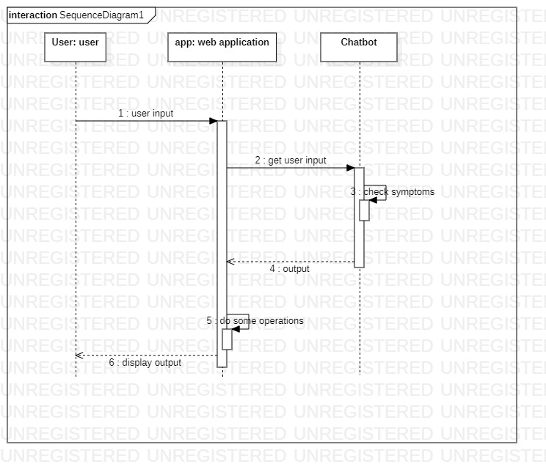
Fig. 4.1 Sequence diagram

4.8 Activity diagram:

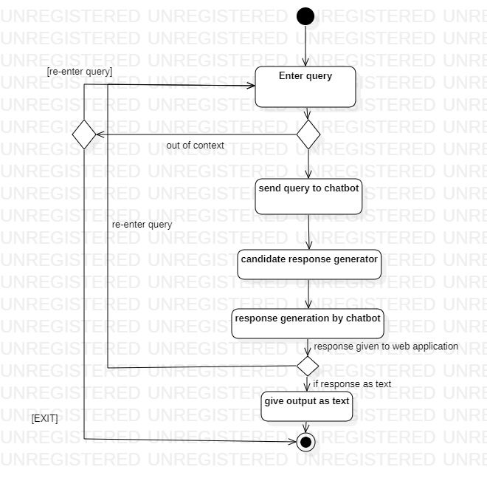
Fig. 4.2 Activity diagram

Chapter - 5

Implementation and Testing

5.1 Implementation Details

index.html- It is the front end of our application. It is present under the folder named templets. When Flask server is run it looks for index HTML (Hypertext Markup Language) file with specified name in our case “index.html”. For styling it uses CSS (Cascading Style Sheets), it uses <style> and </style> tags to bind CSS to every html element on our web page. Its functioning is achieved by JavaScript logic. Every HTML element is identified by its “id attribute” and when a user clicks or performs any action a JavaScript function is called depending on the id of the element on which the action was performed.

run.py- It is most important file for our project. When we run this file, it creates a flask server at local host. It uses the ChatterBotCorpusTrainer to train the saved data folder named /data and uses the db.sqlite3 . It renders ‘chat.html’ file from templets folder and display it as our index page on local host. It contains logic to read user input .Then it will send this response back to chat.html file to display to our users.

train.py – This file used to train the data. It uses the chatterbot trainer. All trained data are located in file named “db.sqlite”. It first check for the file and then update the contents of the file. The database is hosted using SQLite. This allows easy store and handling of the database. There are tables in the database, with an appropriate structure parallel to that in a disease and symptoms. All operations on the database is done using Python commands using a connector library .

saved_conversations – We are using it to store any conversation which can be beneficial in future. When a user is interacting with chatbot and feels that it is having a good conversation or there is some new information that he/she wants to store. It will save the current conversation to directory named /saved_conversations.

5.2 Test Cases

5.2.1 Turing test

It is the most standard test which is being done in the chatbot. Even through most of the chatboats which are currently be seen now days can’t pass the turning test completely but it gives the somewhat idea about the working and errors. Mostly it gives idea about its answers and patterns, how it is behaving, what type of in appropriate or wrong responses does it give. Most basic and common feature it test is humanity and intelligence.

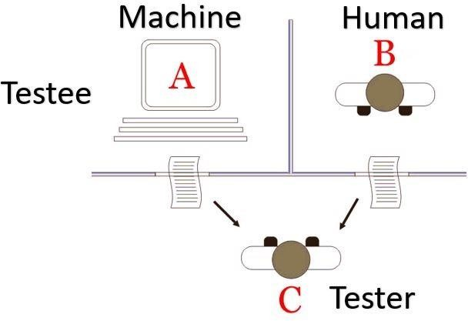

Fig. 5.1 Turing Test

Imagine a game of three players having two humans and one computer, an interrogator (as human) is isolated from other two players. The interrogator job is to try and figure out which one is human and which one is computer by asking questions from both of them. To make the things harder computer is trying to make the interrogator guess wrongly. In other words computer would try to indistinguishable from human as much as possible.
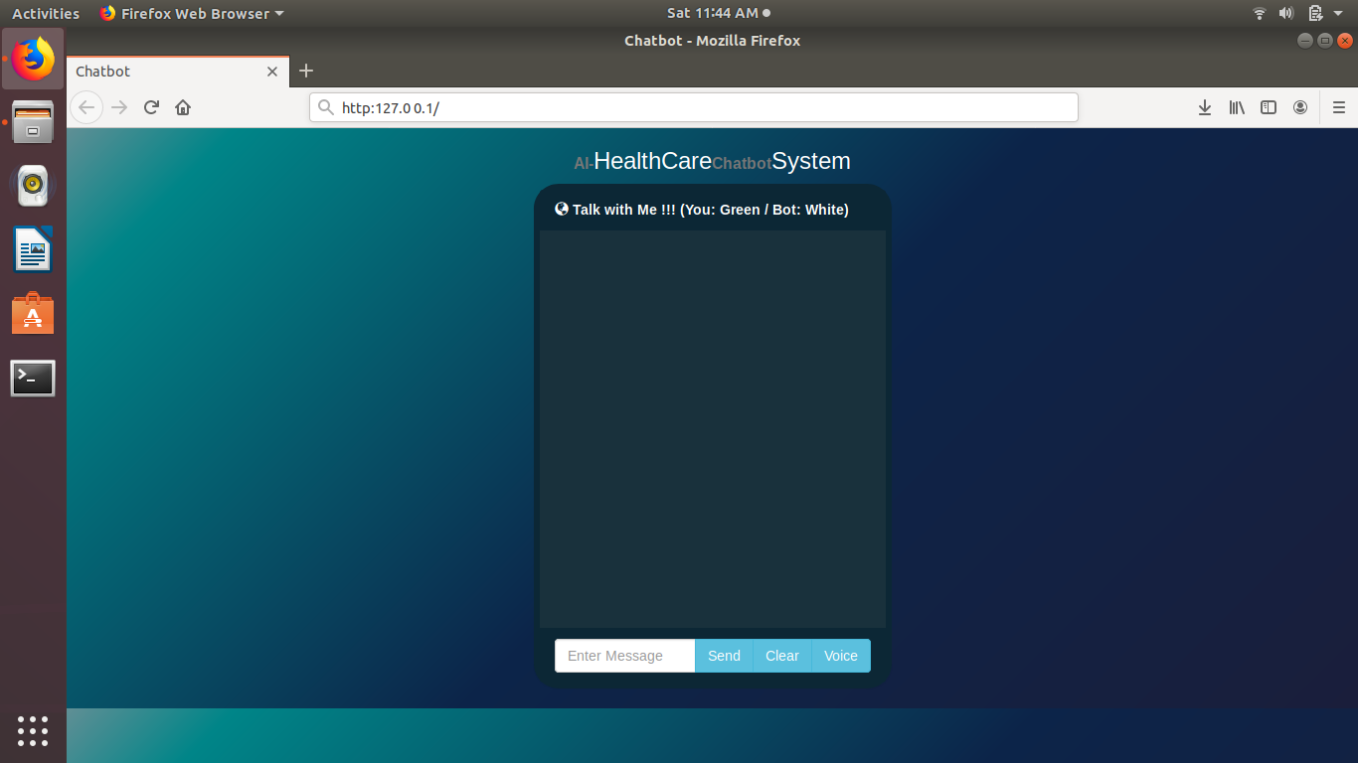

Fig. 5.2 project demo

We are conducted Turing test for our chatbot above are the responses by our chatbot with the ‘JUDGE’.As there is no standard responses to chatbot it varies person to person how it interpret, respond and judge this chatbot.
If our chatbot doesn’t know, it will deflect – change the subject, ask an unrelated question, give a canned or cagey response. Which, in real world, works decently well in human-human dialogue as well.

Why is it difficult to test a chatbot?

There is no fixed format or guidelines of chatbot testing. The real testing of chatbot happens when it reaches real human users. As every human is different, his/her perception of chatbot quality may differ. Hence user feedback is of priority for a chatbot developer. As a chatbot is used more and more it accumulates more conversation, trains itself and becomes better. Only thing as a developer you can test is your framework and your logic and let the chatbot learn.

Chapter – 6

Conclusion

Overall we feel that working on this project provided us with a great learning experience. This has been our first major college project that was completely solely by us so it taught us a lot in terms of time management and work load management. our favourite part of this project was working on an area of computing that is really starting to grow and break into the mainstream market. With so many companies getting on board by creating their own chatbots, in a few years we will see it as an everyday thing. It has been great to work with soft Bots Framework that is still in development and more and more features being added each day. Regrettably, we feel that we did spend a lot of time working with chatterbot python library before I moved on to Bot Framework, we feel that if we had have been working with Bot Framework from the start, we would’ve achieved a lot more. The feedback from our project mentor at our mid-point presentation really set us in the right direction. In the future, we will remember to be realistic with the goals we set ourselves and to explore every available option to us before committing to one framework. Although this project was great to work on, we are disappointed that we did not get to implement any of the security features that we have learned about in my other modules completed in previous semesters. We have learned a lot in the security aspect of computing from our other modules but it has been a learning experience developing this application as it touched on areas that we have never worked with before which gave me a challenging but beneficial experience.

REFRENCES

[1]. SimonHoermann, Kathryn L McCabe, David N Milne, Rafael A Calvo1,“ Application of Synchronous Text-Based Dialogue Systems in Mental Health Interventions: Systematic Review”, Journal of Medical Internet Research ,volume: 19 , issue 8 , August 2017.

[2]. Saurav Kumar Mishra, DhirendraBharti, Nidhi Mishra,” Dr.Vdoc: A Medical Chatbot that Acts as aVirtual Doctor”, Journal of Medical Science and Technology ,Volume: 6, Issue 3,2017.
[3]. DivyaMadhu,Neeraj Jain C. J, ElmySebastain, ShinoyShaji, AnandhuAjayakumar,” A Novel Approach for Medical Assistance Using Trained Chatbot”,International Conference on Inventive Communication and Computational Technologies(ICICCT 2017).

[4]. HameedullahKazi,B.S. Chowdhry,ZeeshaMemon, ”MedChatBot: An UMLS based Chatbot for Medical Students”, International Journal of Computer Applications (0975 – 8887)Volume 55– No.17, October 2016.
[5]. DoinaDrăgulescu,AdrianaAlbu,”Medical Predictions System”, International Journal of Engineering Research and Applications , ISSN: 2248-9622 ,Vol. 2, Issue 3 , pp.1988-1996, May-Jun 2015.
[6]. Abbas SaliimiLokman, JasniMohamadZain,FakultiSistemKomputer, KejuruteraanPerisian,” Designing a Chatbot for Diabetic Patients”,ACM Transactions on Management Information Systems (TMIS), Volume 4, Issue 2, August 2015 .
[7]. PavlidouMeropi,Antonis S. Billis,Nicolas D. Hasanagas,CharalambosBratsas,IoannisAntoniou,Panagiotis D. Bamidis,”Conditional Entropy Based Retrieval Model in Patient-Carer Conversational Cases”,2017 IEEE 30th International conference on Computer-Based Medical System.

[8]. BenildaEleonor V. Comendador, Bien Michael B. Francisco, Jefferson S. Medenilla, Sharleen Mae T. Nacion, and Timothy Bryle E. Serac, “Pharmabot: A Pediatric Generic Medicine Consultant Chatbot “,Journal of Automation and Control Engineering Vol. 3, No. 2, April 2015.

[9]. Gillian Cameron, David Cameron, Gavin Megaw ,Raymond Bond,MauriceMulvenna ,Siobhan O’Neill, Cherie Armour, Michael McTear,“Towards a chatbot for digital counselling”,Journal of Medical Internet Research, 4(1), pp. e3.

